**Exploration and Visualisation of Dataset**

**Ezhil Arasu E**

**310619104033**

**Team ID PNT2022TMID09262**

R&D Spend by Administration

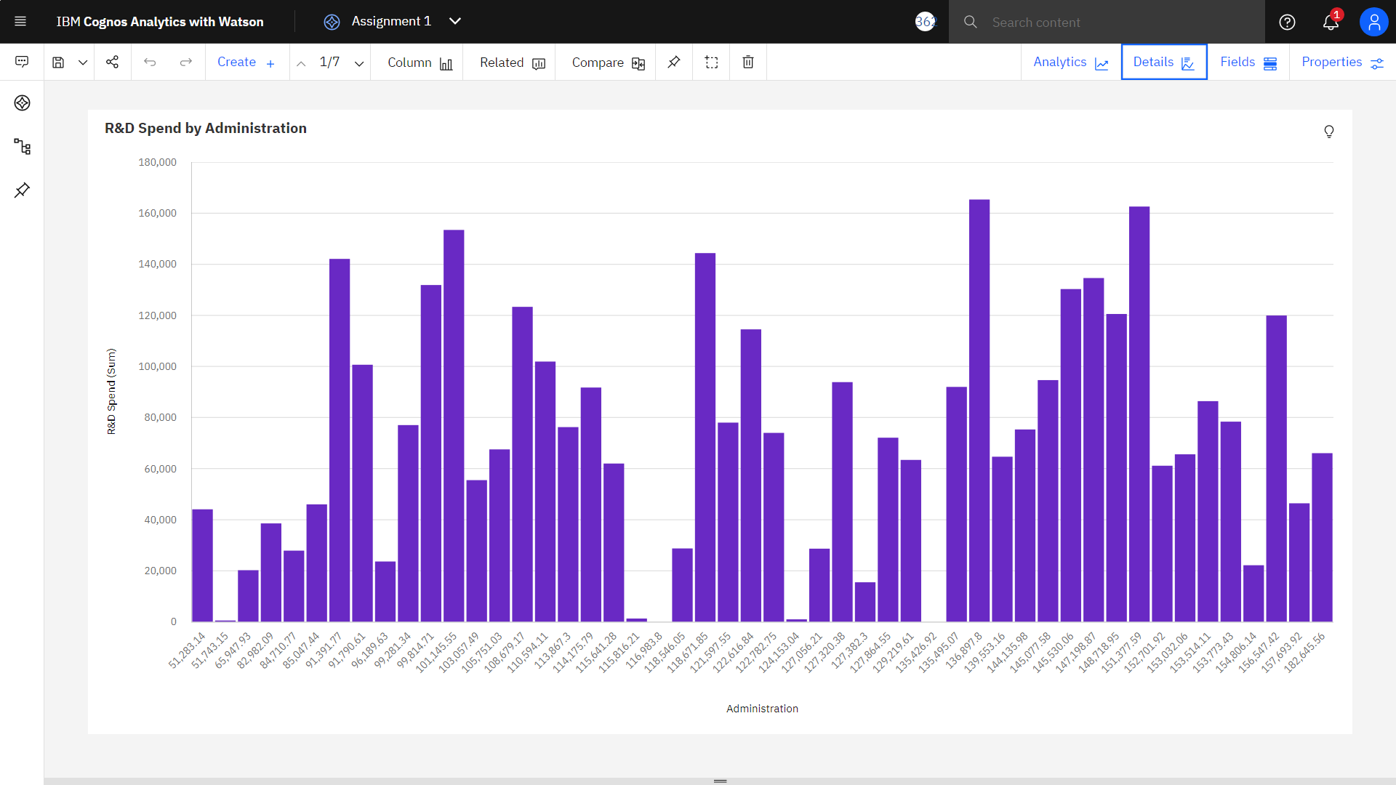

Marketing Spend by R&D Spend

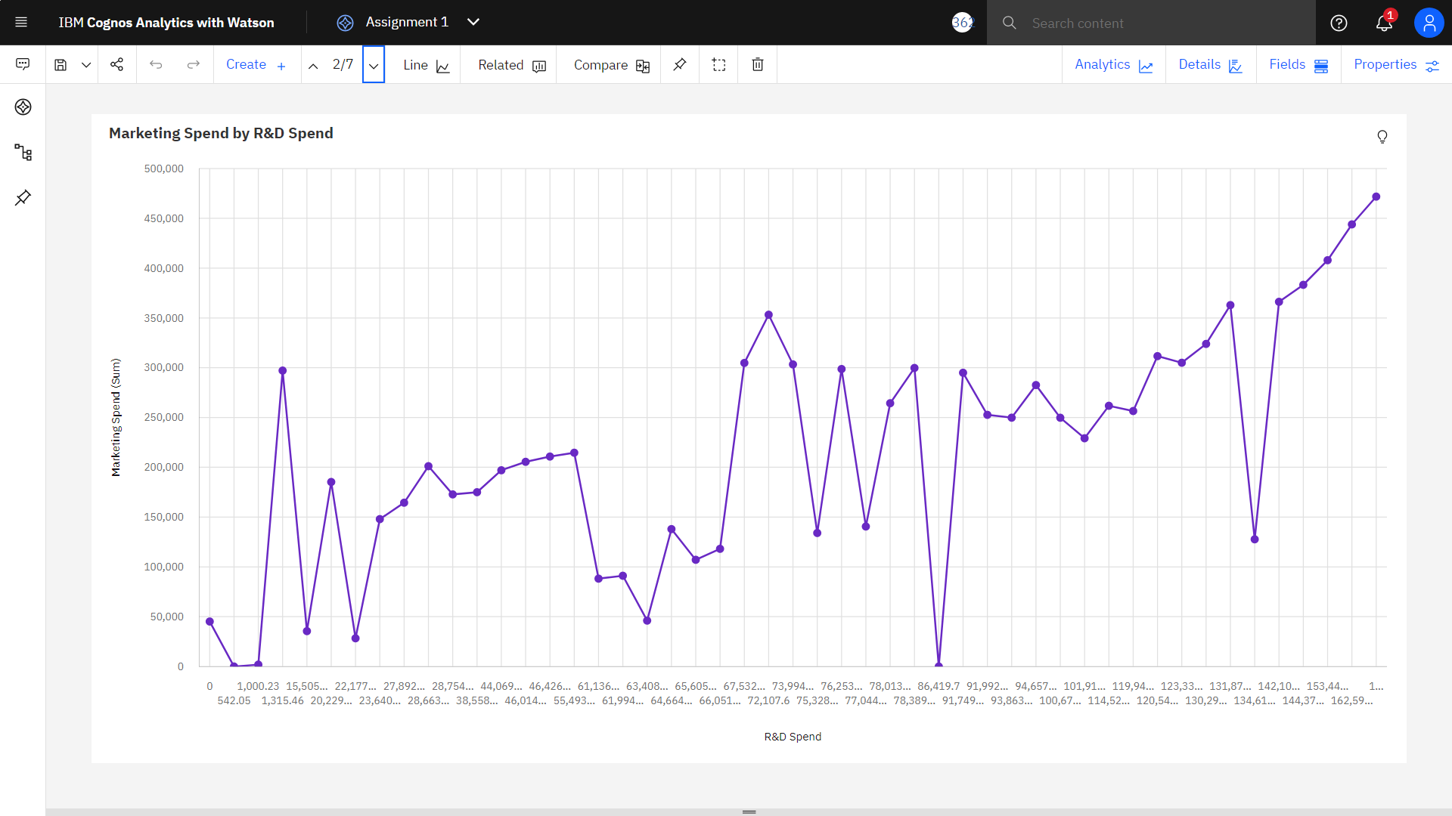

Marketing Spend by R&D Spend

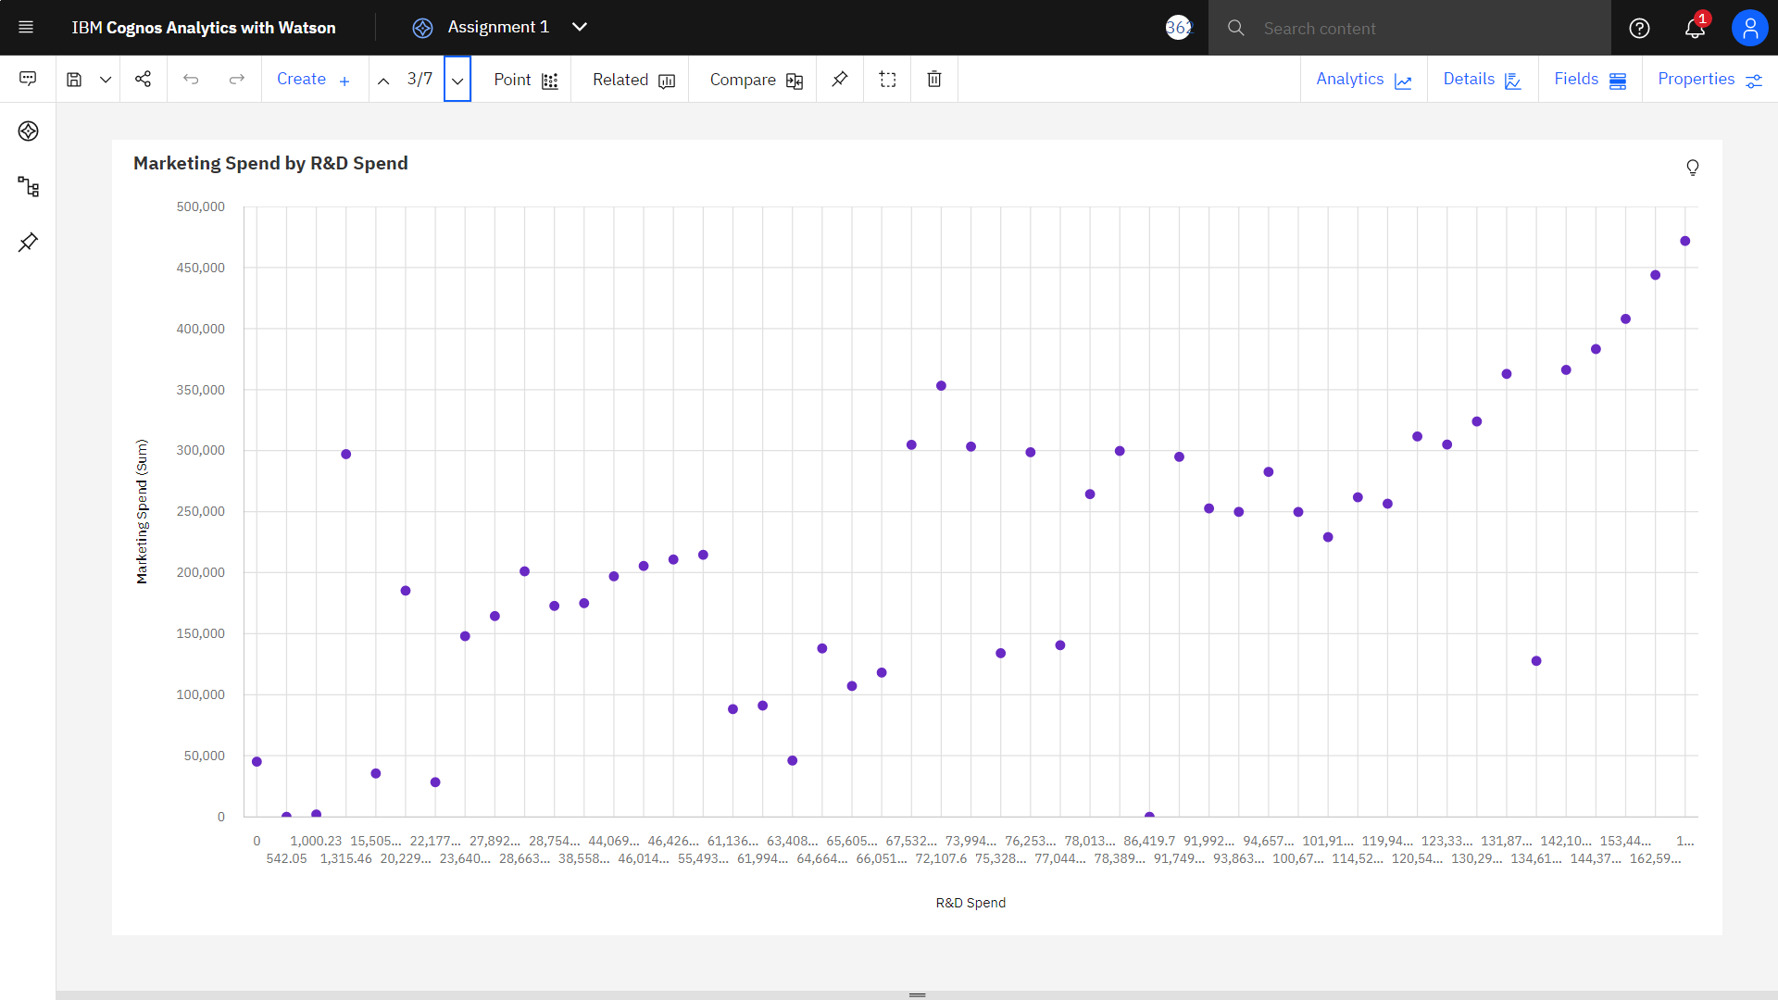

Marketing Spend by R&D Spend and Administration

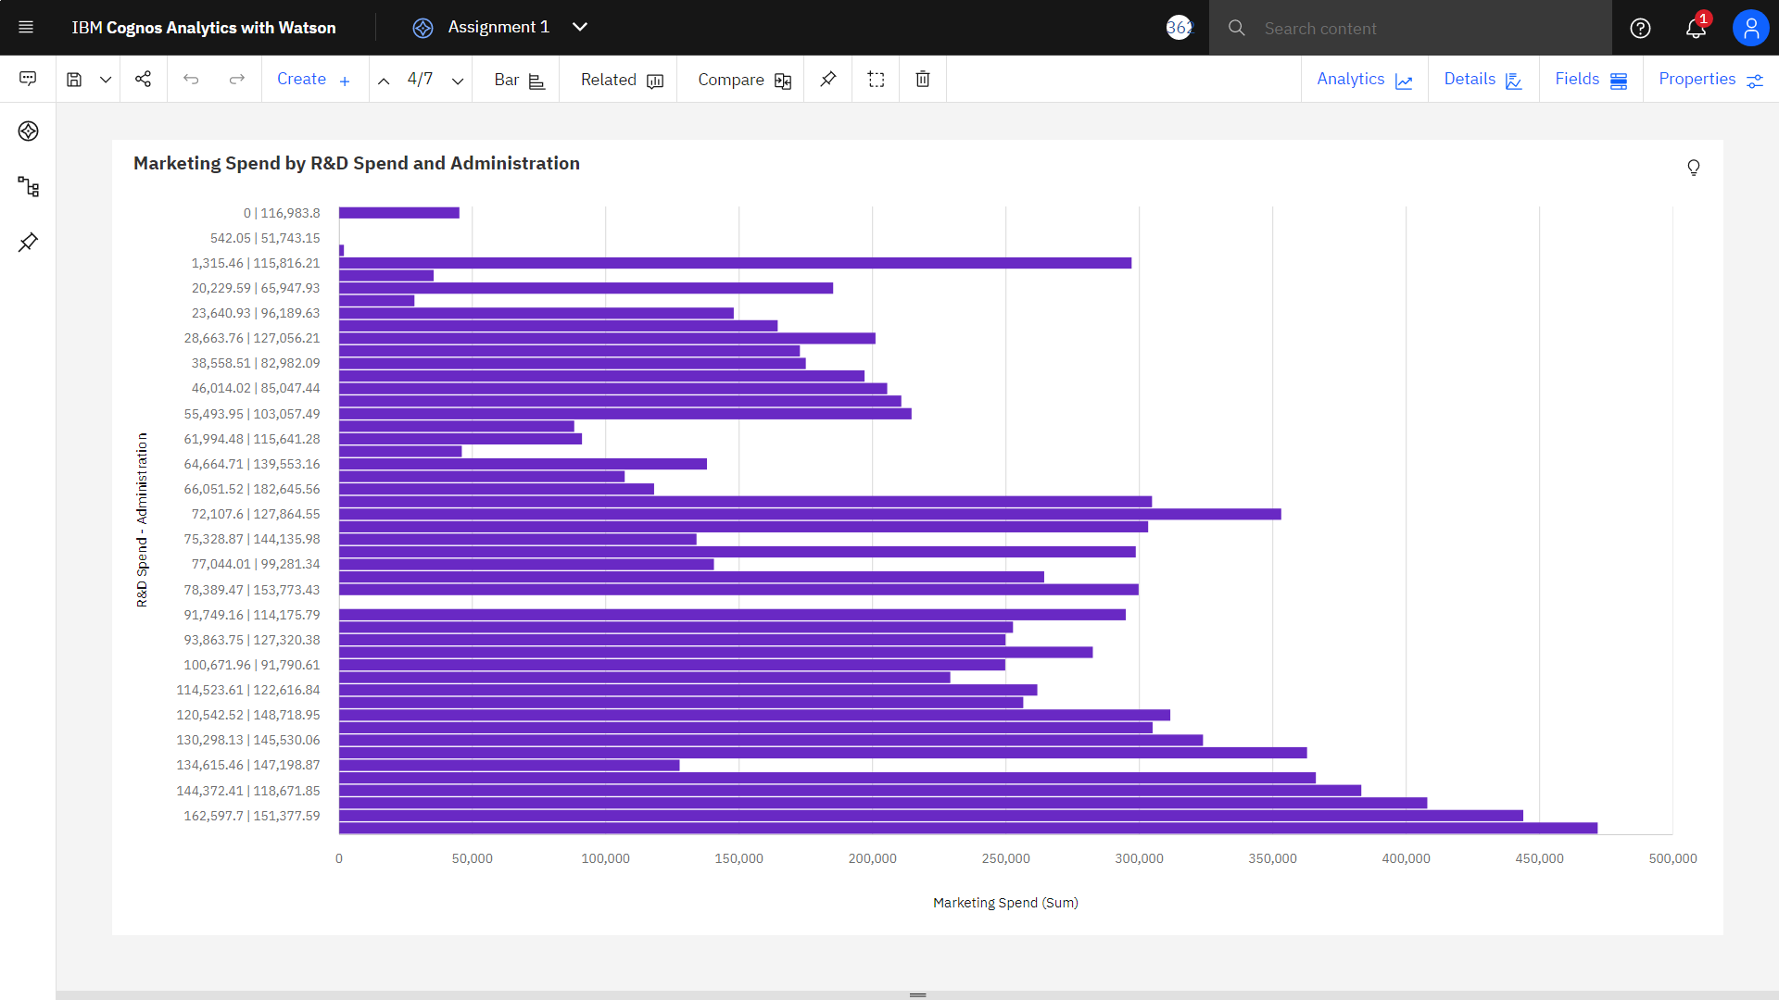

Profit by R&D Spend and Marketing Spend

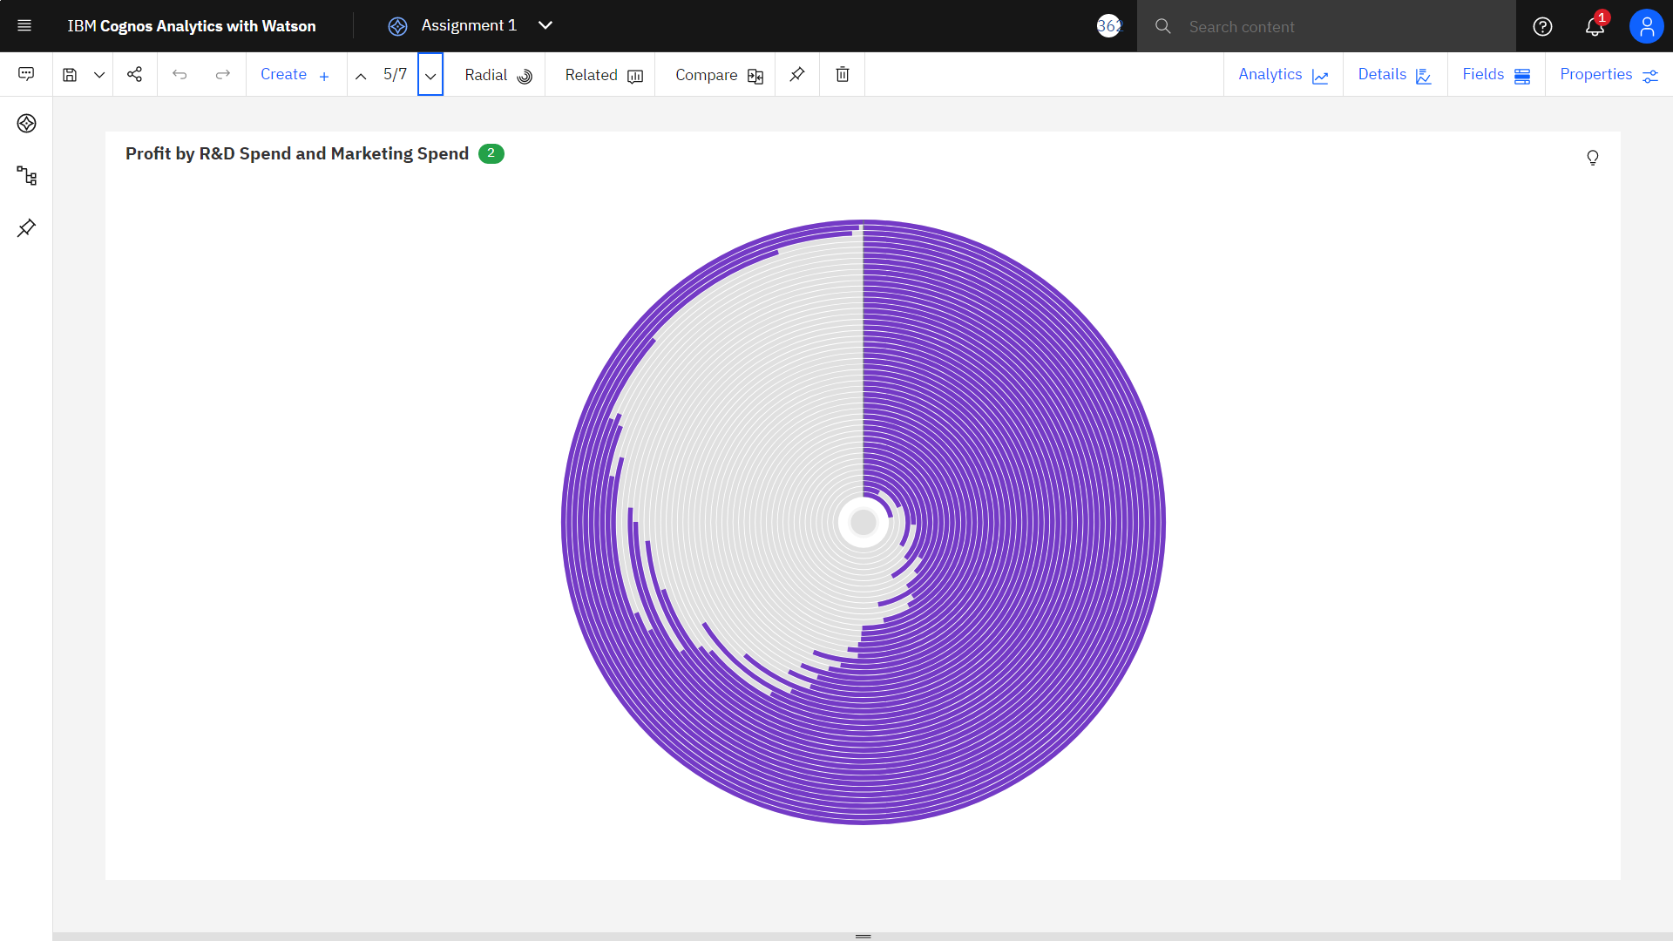

Profit, R&D Spend and Administration by Marketing Spend

